1. **Create a Spring Web Project using Maven**

**SpringLearnApplication.java**

package com.cognizant.springlearn;

import org.springframework.boot.SpringApplication;

import org.springframework.boot.autoconfigure.SpringBootApplication;

@SpringBootApplication

public class SpringLearnApplication {

public static void main(String[] args) {

System.out.println("SpringLearnApplication started...");

SpringApplication.run(SpringLearnApplication.class, args);

}

}

**Output:**

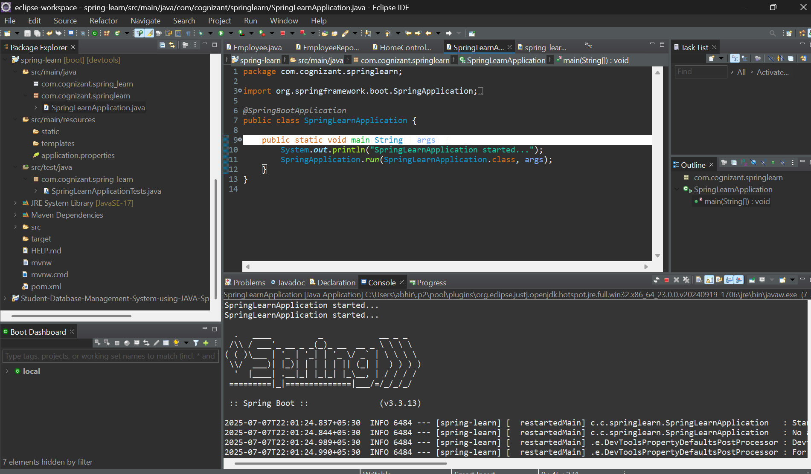

**4.Spring Core – Load Country from Spring Configuration XML**

**Country.java**

package com.cognizant.springlearn;

import org.slf4j.Logger;

import org.slf4j.LoggerFactory;

public class Country {

private String code;

private String name;

private static final Logger ***LOGGER*** = LoggerFactory.*getLogger*(Country.class);

public Country() {

***LOGGER***.debug("Inside Country Constructor.");

}

public String getCode() {

***LOGGER***.debug("Inside getCode");

return code;

}

public void setCode(String code) {

***LOGGER***.debug("Inside setCode");

this.code = code;

}

public String getName() {

***LOGGER***.debug("Inside getName");

return name;

}

public void setName(String name) {

***LOGGER***.debug("Inside setName");

this.name = name;

}

*@Override*

public String toString() {

return "Country [code=" + code + ", name=" + name + "]";

}

}

**Country.xml**

<?xml version=*"1.0"* encoding=*"UTF-8"*?>

<beans xmlns=*"http://www.springframework.org/schema/beans"*

xmlns:xsi=*"http://www.w3.org/2001/XMLSchema-instance"*

xsi:schemaLocation=*"http://www.springframework.org/schema/beans*

*http://www.springframework.org/schema/beans/spring-beans.xsd"*>

<bean id=*"country"* class=*"com.cognizant.springlearn.Country"*>

<property name=*"code"* value=*"IN"* />

<property name=*"name"* value=*"India"* />

</bean>

</beans>

**SpringLearnApplicatiom.java**

package com.cognizant.springlearn;

import org.slf4j.Logger;

import org.slf4j.LoggerFactory;

import org.springframework.context.ApplicationContext;

import org.springframework.context.support.ClassPathXmlApplicationContext;

public class SpringLearnApplication {

private static final Logger *LOGGER* = LoggerFactory.*getLogger*(SpringLearnApplication.class);

*@SuppressWarnings*("resource")

public static void displayCountry() {

ApplicationContext context = new ClassPathXmlApplicationContext("country.xml");

Country country = context.getBean("country", Country.class);

*LOGGER*.info("Country : {}", country.toString());

System.*out*.println(country);

}

public static void main(String[] args) {

*displayCountry*();

}

}

**Output:**

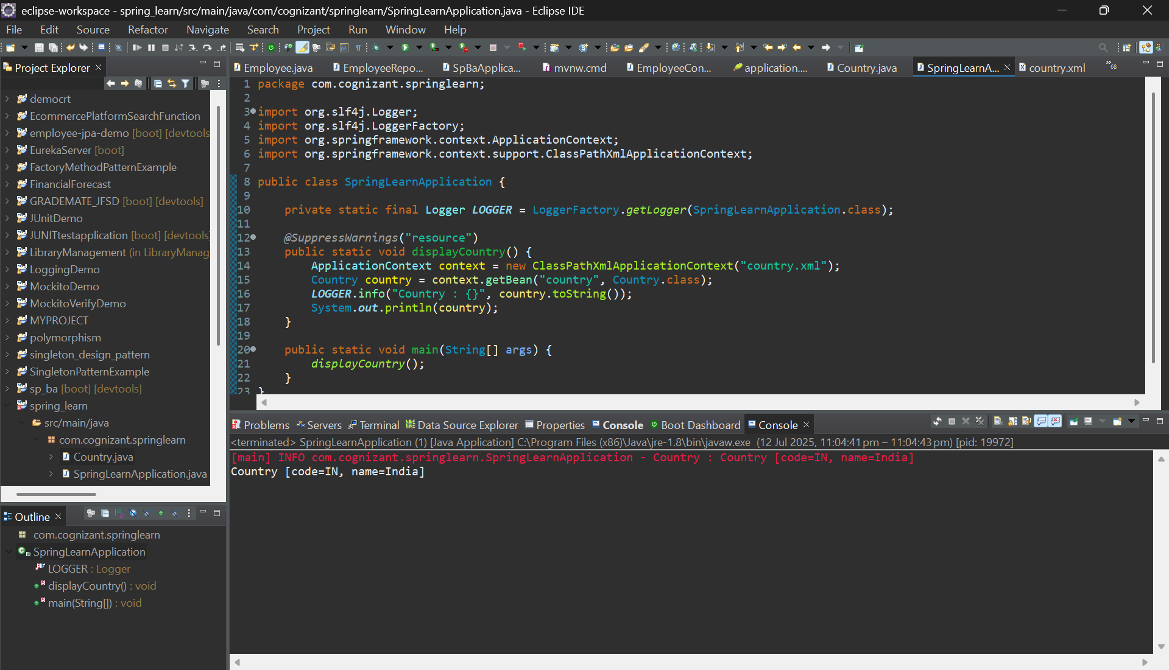

**Hello World RESTful Web Service**

**HelloController.java**

package com.cognizant.springlearn.controller;

import org.slf4j.Logger;

import org.slf4j.LoggerFactory;

import org.springframework.web.bind.annotation.GetMapping;

import org.springframework.web.bind.annotation.RestController;

*@RestController*

public class HelloController {

private static final Logger *LOGGER* = LoggerFactory.*getLogger*(HelloController.class);

*@GetMapping*("/hello")

public String sayHello() {

*LOGGER*.info("START sayHello()");

String message = "Hello World!!";

*LOGGER*.info("END sayHello()");

return message;

}

}

**Output:**

**REST - Country Web Service**

**country.xml**

<?xml version="1.0" encoding="UTF-8"?>

<beans xmlns="http://www.springframework.org/schema/beans"

xmlns:context="http://www.springframework.org/schema/context"

xmlns:xsi="http://www.w3.org/2001/XMLSchema-instance"

xsi:schemaLocation="http://www.springframework.org/schema/beans

https://www.springframework.org/schema/beans/spring-beans.xsd

http://www.springframework.org/schema/context

https://www.springframework.org/schema/context/spring-context.xsd">

<bean id="country" class="com.cognizant.springlearn.Country">

<property name="code" value="IN" />

<property name="name" value="India" />

</bean>

</beans>

**Country.java**

package com.cognizant.springlearn;

public class Country {

private String code;

private String name;

// Getters and setters

public String getCode() {

return code;

}

public void setCode(String code) {

this.code = code;

}

public String getName() {

return name;

}

public void setName(String name) {

this.name = name;

}

}

**CountryController.java**

package com.cognizant.springlearn.controller;

import com.cognizant.springlearn.Country;

import org.slf4j.Logger;

import org.slf4j.LoggerFactory;

import org.springframework.context.ApplicationContext;

import org.springframework.context.support.ClassPathXmlApplicationContext;

import org.springframework.web.bind.annotation.RequestMapping;

import org.springframework.web.bind.annotation.RestController;

@RestController

public class CountryController {

private static final Logger LOGGER = LoggerFactory.getLogger(CountryController.class);

@RequestMapping("/country")

public Country getCountryIndia() {

LOGGER.info("START getCountryIndia()");

ApplicationContext context = new ClassPathXmlApplicationContext("country.xml");

Country country = (Country) context.getBean("country");

LOGGER.info("END getCountryIndia()");

return country;

}

}

Output:

**REST - Get country based on country code**

**Country.xml**

**<?xml version="1.0" encoding="UTF-8"?>**

**<beans xmlns="http://www.springframework.org/schema/beans"**

**xmlns:xsi="http://www.w3.org/2001/XMLSchema-instance"**

**xsi:schemaLocation="http://www.springframework.org/schema/beans**

**https://www.springframework.org/schema/beans/spring-beans.xsd">**

**<bean id="countryList" class="java.util.ArrayList">**

**<constructor-arg>**

**<list>**

**<bean class="com.cognizant.springlearn.Country">**

**<property name="code" value="IN" />**

**<property name="name" value="India" />**

**</bean>**

**<bean class="com.cognizant.springlearn.Country">**

**<property name="code" value="US" />**

**<property name="name" value="United States" />**

**</bean>**

**<bean class="com.cognizant.springlearn.Country">**

**<property name="code" value="DE" />**

**<property name="name" value="Germany" />**

**</bean>**

**<bean class="com.cognizant.springlearn.Country">**

**<property name="code" value="JP" />**

**<property name="name" value="Japan" />**

**</bean>**

**</list>**

**</constructor-arg>**

**</bean>**

**</beans>**

**CountryService.java**

**package com.cognizant.springlearn.service;**

**import com.cognizant.springlearn.Country;**

**import org.springframework.context.ApplicationContext;**

**import org.springframework.context.support.ClassPathXmlApplicationContext;**

**import org.springframework.stereotype.Service;**

**import java.util.List;**

**@Service**

**public class CountryService {**

**public Country getCountry(String code) {**

**ApplicationContext context = new ClassPathXmlApplicationContext("country.xml");**

**List<Country> countryList = context.getBean("countryList", List.class);**

**// Using Lambda expression to match country code case-insensitively**

**return countryList.stream()**

**.filter(country -> country.getCode().equalsIgnoreCase(code))**

**.findFirst()**

**.orElse(null); // You can handle null with proper exception if needed**

**}**

**}**

**CountryController.java**

**package com.cognizant.springlearn.controller;**

**import com.cognizant.springlearn.Country;**

**import com.cognizant.springlearn.service.CountryService;**

**import org.slf4j.Logger;**

**import org.slf4j.LoggerFactory;**

**import org.springframework.beans.factory.annotation.Autowired;**

**import org.springframework.web.bind.annotation.*;**

**@RestController**

**public class CountryController {**

**private static final Logger LOGGER = LoggerFactory.getLogger(CountryController.class);**

**@Autowired**

**private CountryService countryService;**

**@GetMapping("/countries/{code}")**

**public Country getCountry(@PathVariable String code) {**

**LOGGER.info("START getCountry() with code: {}", code);**

**Country country = countryService.getCountry(code);**

**LOGGER.info("END getCountry()");**

**return country;**

**}**

**}**

**Output:**

